

*[Geophysical Research Letters]*

Supporting Information for

**A snapshot of New Zealand's dynamic deformation field from Envisat InSAR and GPS observations between 2003 and 2011**

[Ian. J. Hamling1, Tim J Wright2, Sigrun Hreinsdóttir1 and Laura M Wallace1,3]

[1. GNS Science, 2. School of Earth and Environment, University of Leeds, 3. Univesity of Tas at Austin]

**Contents of this file**

Supporting figures S1-S11

Table S1

**Additional Supporting Information**

NZ_InSAR_GPS.zip contains the full InSAR derived velocity files, Vertical GPS and 1 km coastal strip.

GPS Processing:

W use GPS data spanning the equivalent time period as the InSAR observations, nominally 2003 to 2011. The GPS data were analyzed using the GAMIT/GLOBK version 10.5 using over 100 global CGPS stations in the analysis to evaluate site positions in the ITRF08 reference frame. In the analysis we solved for station coordinates, satellite orbit, and earth rotation parameters, estimating atmospheric zenith delays every 2 hour and using three atmospheric gradients per day. We used the IGS08 azimuth and elevation-dependent absolute phase centre model with an elevation cutoff angle of 10°for the ground based antennas and applied the FES2004 ocean loading model.

|  |  |
| --- | --- |
|  |  |

**Figure S1**: Left) Outlines of all 20 ascending tracks used in this study with their associated track numbers. Right) Locations of GNSS sites across New Zealand. The black triangles are all the continuous and campaign data from Beavan et al., (2016) and the red circles are the GNSS covering the same period as the InSAR data presented in the main manuscript.

|  |  |
| --- | --- |
| Track 65 | Track 337 |
| Track 108 | Track 380 |

**Figure S2**: Baseline-time plots for tracks 65, 337, 108 and 380 (Figure S1).

|  |  |
| --- | --- |
| Track 151 | Track 423 |
| Track 194 | Track 466 |

**Figure S3**: Baseline-time plots for tracks 151, 423, 194, and 466 (Figure S1).

|  |  |
| --- | --- |
| Track 237 | Track 8 |
| Track 280 | Track 51 |

**Figure S4**: Baseline-time plots for tracks 237, 8, 280 and 51 (Figure S1).

|  |  |
| --- | --- |
| Track 323 | Track 94 |
| Track 366 | Track 137 |

**Figure S5**: Baseline-time plots for tracks 323,94,366, and 137 (Figure S1).

|  |  |
| --- | --- |
| Track 409 | Track 452 |
| Track 223 | Track 495 |

**Figure S6**: Baseline-time plots for tracks 409,452, 223, and 495 (Figure S1).

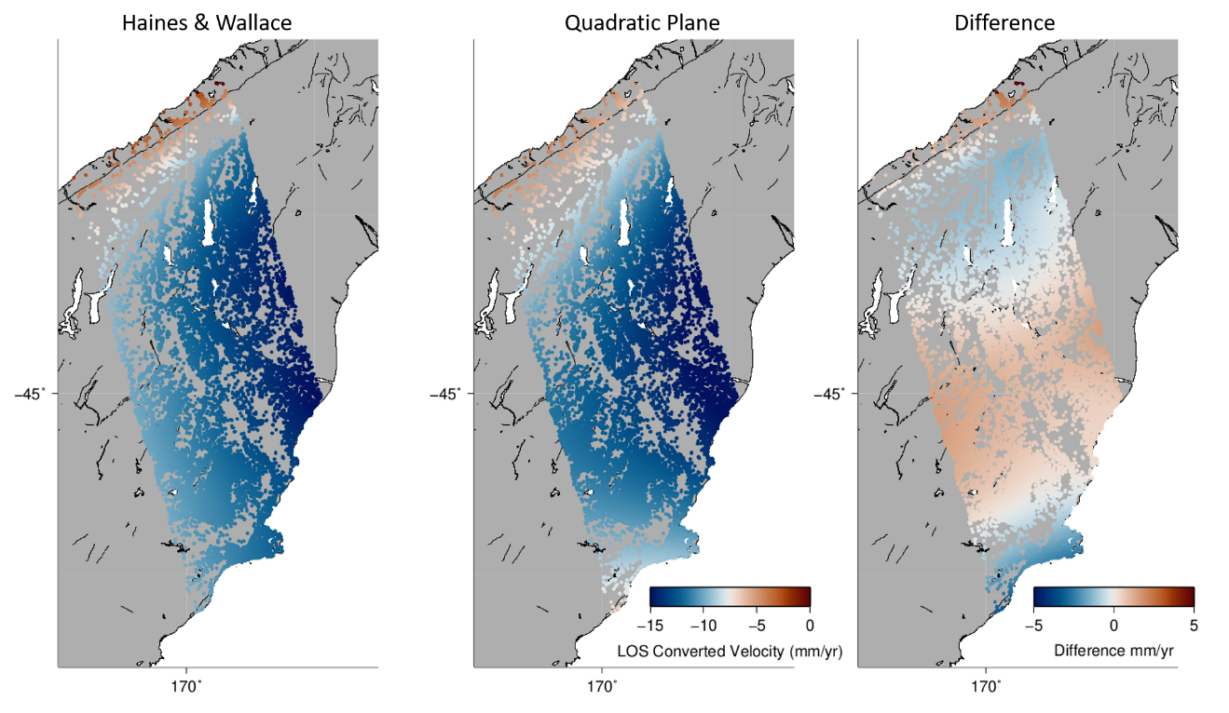

**Figure S7.** Comparison between the horizontal component of the displacement field extracted from Haines and Wallace (2020) with a quadratic plane fitted to the GNSS velocities.

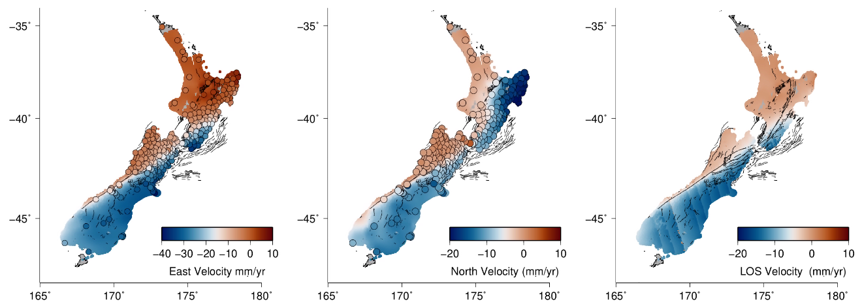

**Figure S8**. East, north and LOS velocity from Wallace and Haines extracted for each of the scatterers in the InSAR dataset. The large dots show the location of the GNSS spanning the same time period as the InSAR data and are color coded by the displacement rate.

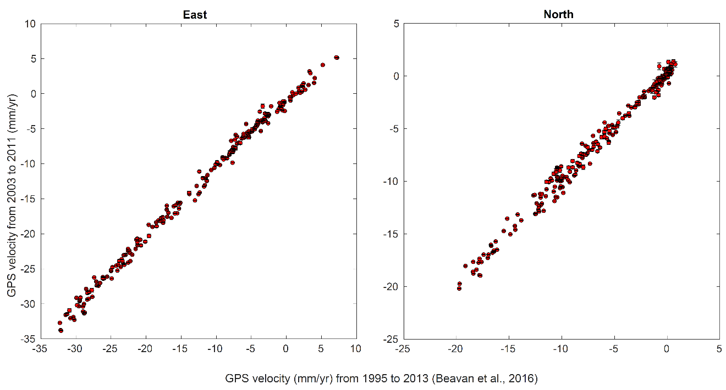

**Figure S9**. Comparison between East and North velocites derived for the InSAR observation period and longer term velocities from Beavan et al., 2016.

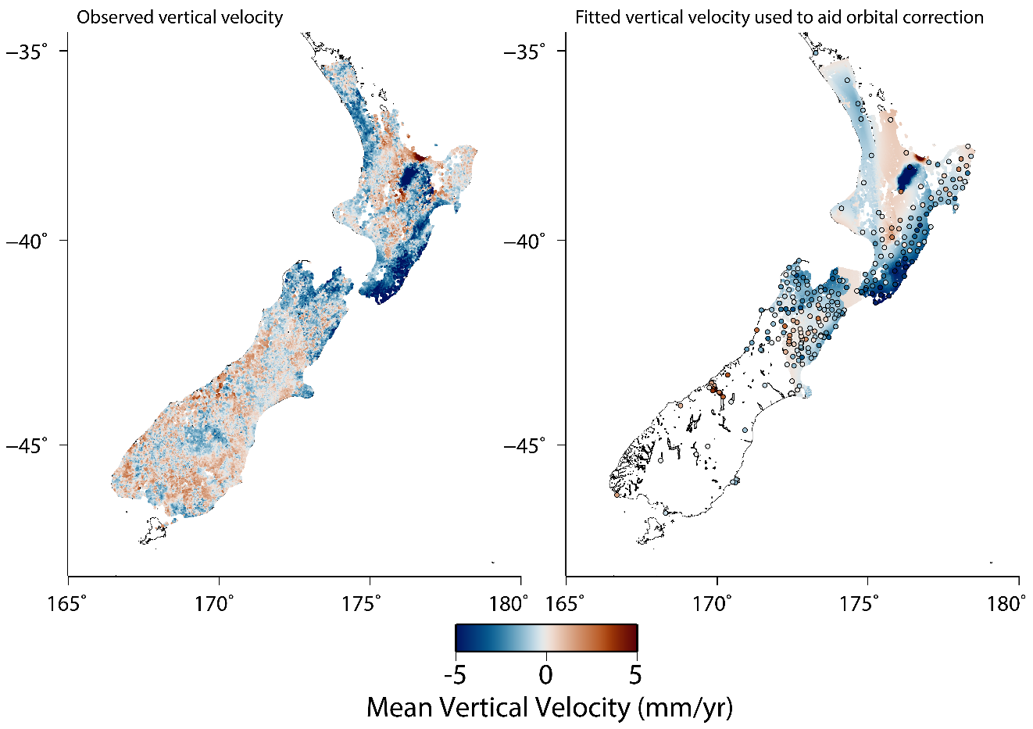

Figure S10. *Left)* Derived vertical velocity field based on the InSAR and GPS dataset. *Right)* Fitted vertical elocity field removed prior to corrctions of long wavelength orbital and atmospheric errors. Dots show the vertical rates derived from GPS over the same observation period as the InSAR observations. Note that for majority of the South Island where GPS are sparse we do not apply any a prioi correction.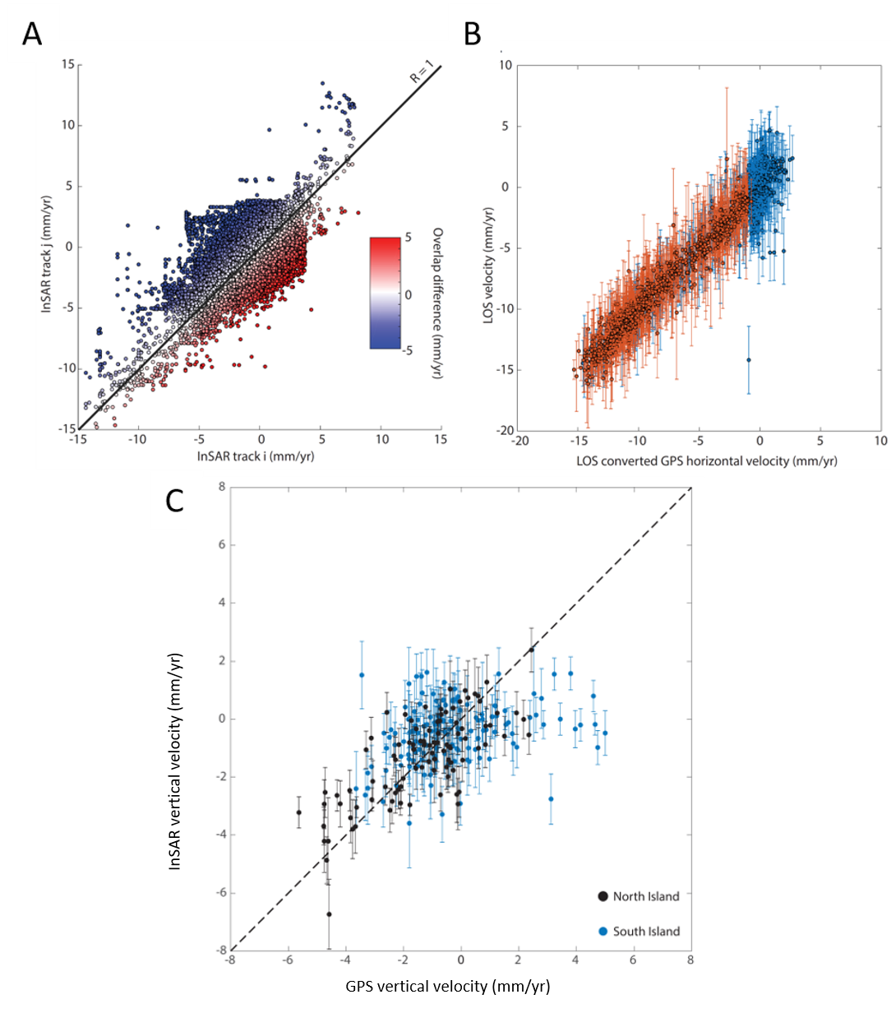

Figure S11. A) Scatter plot showing the differene between InSAR velocities in areas with overlapping InSAR tracks. B)Comparison between the InSAR derived horizonal velocities and those from co-located GPS. Error bars show the standard devation based on the collection of scatterers within 1 km of the GPS. C) )Comparison between the InSAR derived vertical velocities and those from co-located GPS. The black and blue lines are for stations on the North and South Islands respectively.



Figure S12. Difference in InSAR velocities in regions with overlapping frames.



Figure S13. 1-σ error for the estimated displacement rates.



Table S1. Categories for deriving quality factors for coastal VLM with category scores shown in brackets. Points with low numbers of observations and large search radii get a high score while points with large numbers of observations and small search radii get a low score.

In determining the quality factIor, each radial distance is allocated a score from 0.5 to 2.5, Table S1) and separately, scores from 0.5 to 2.5 are given to the number of observations within each radial distamce. The final quality factor (QF) of a given point is then the sum of the two individual scores. At each coastal sample point, we loop over the distance bins and select the radius which gives the best quality factor. If more than one radius gives the same score, then then smallest radial distance is selected.